Disease Split
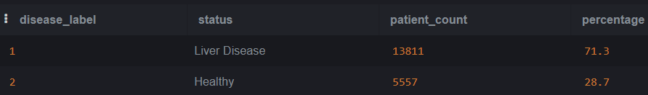
Average Enzyme Levels by Disease
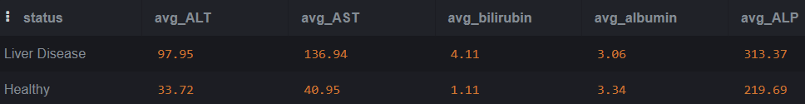
Gender Breakdown
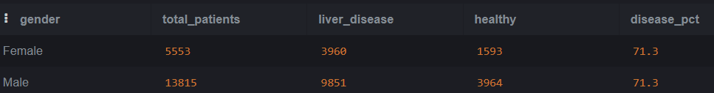
Age Group Analysis
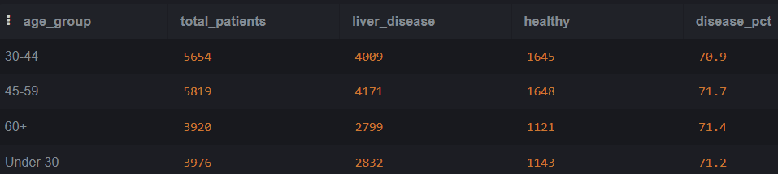
High Risk Patients(Top 5)
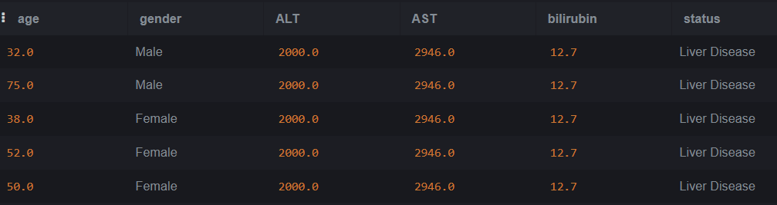
Full Summary Table
